2022-07-03

Cluster11 Electric

(11, 'electric_bike'): {'order': (2, 1, 2),'seasonal_order': (0, 0, 0, 0),'aic': 2132.3092275420267})

769.5677884

632

Actual: 699



Forcasting curve:

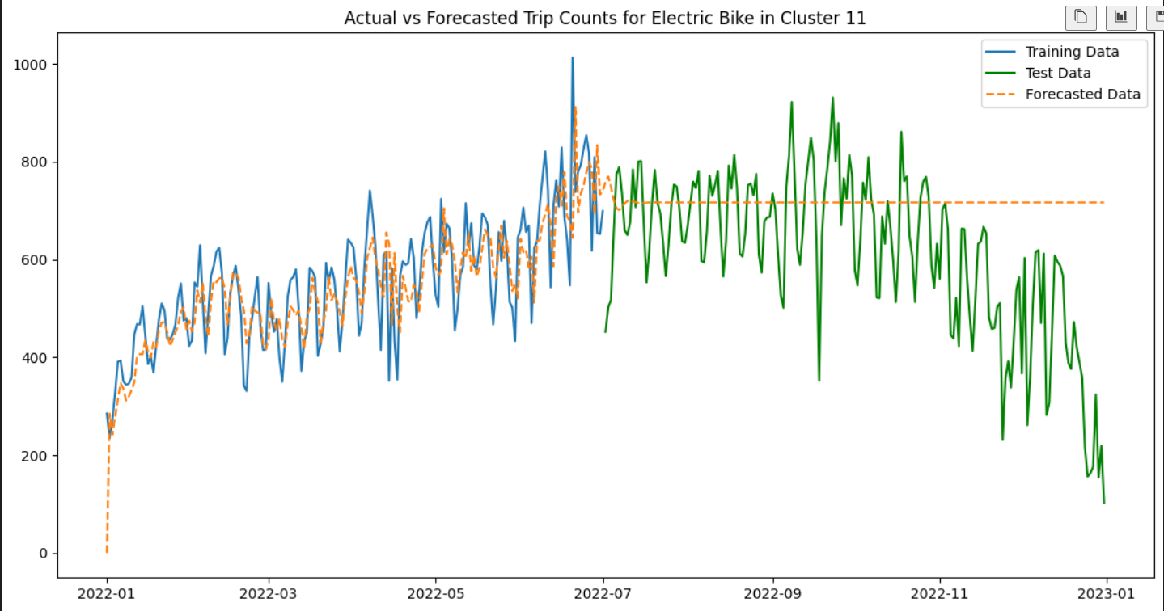

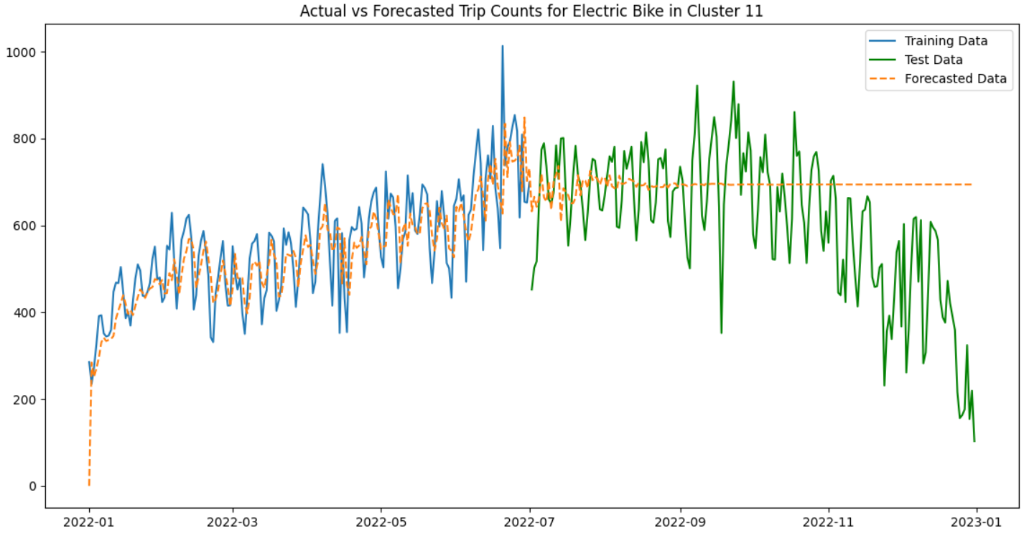

Fitting all the data

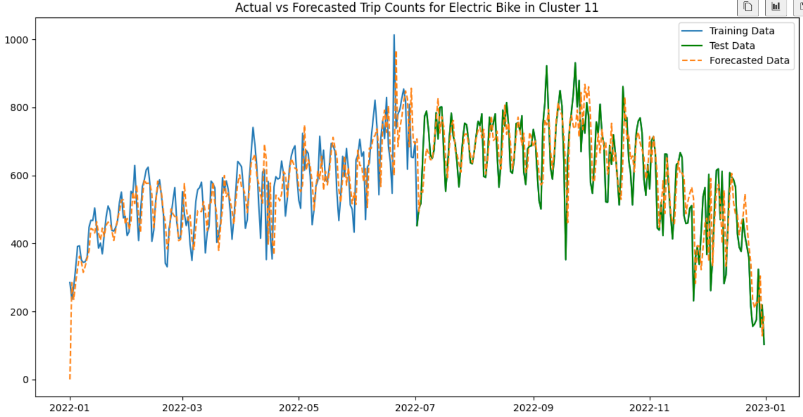

2022-07-03

Cluster16 Electric

(16, 'electric_bike'): {'order': (3, 1, 3),'seasonal_order': (0, 0, 0, 0),'aic': 2187.461868331935})

708.7045622

617.953763

Actual: 764

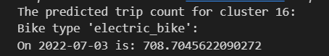

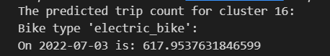

Forcasting curve:

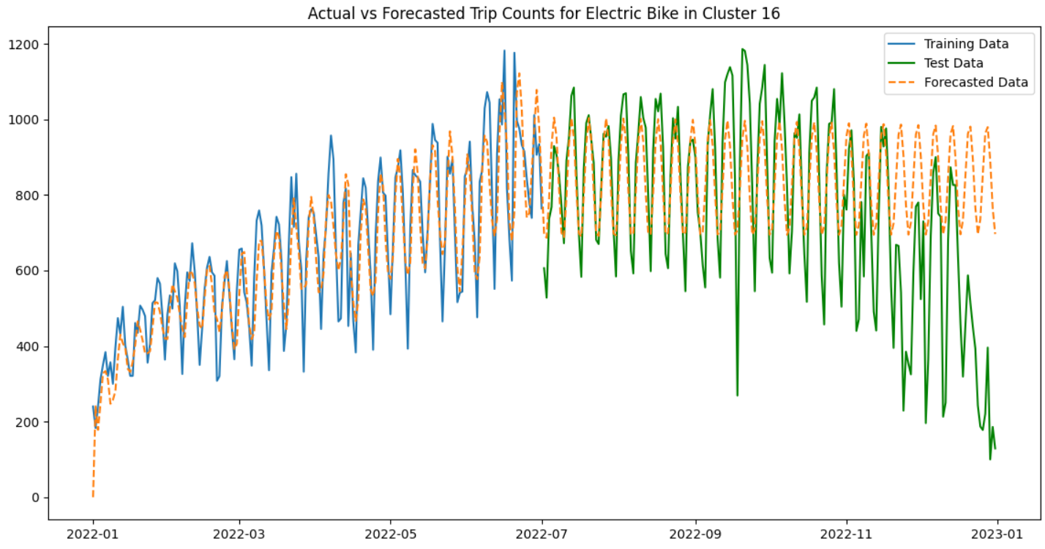

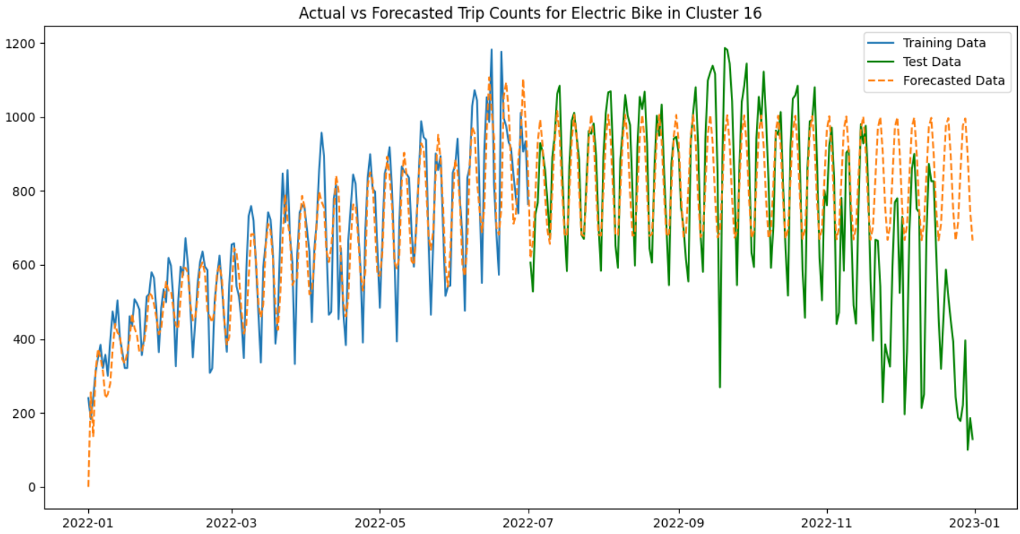

Fitting all the data

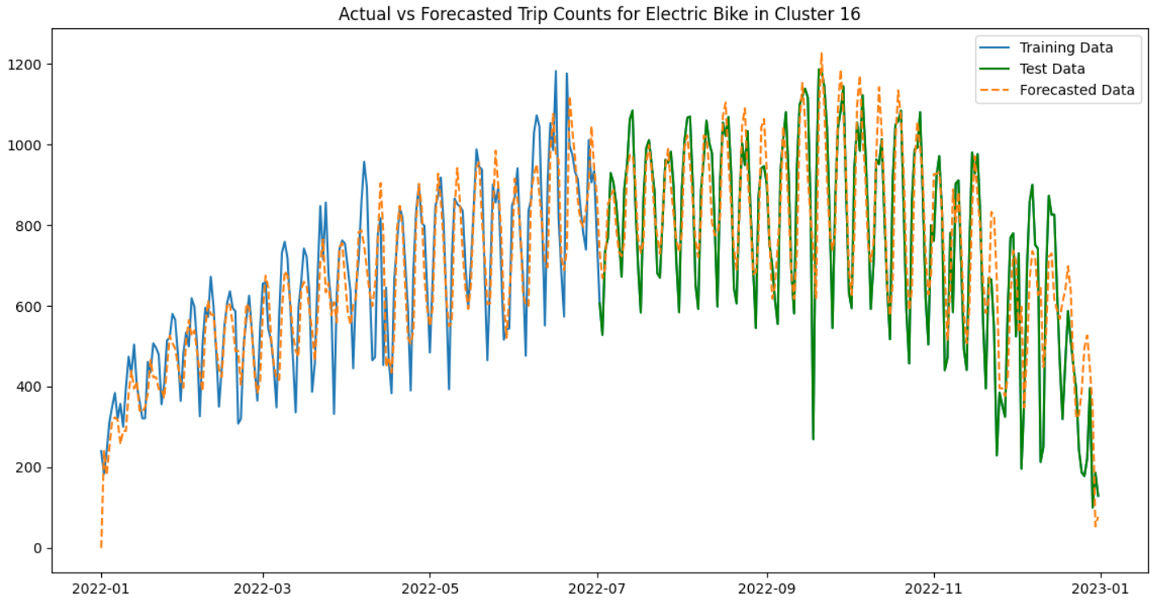

2022-07-03

Cluster17 Electric

(17, 'electric_bike'): {'order': (1, 1, 3),'seasonal_order': (0, 0, 0, 0),'aic': 2489.1048558342536})

1541.0090714

1292.1019485

Actual: 1278

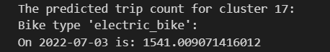

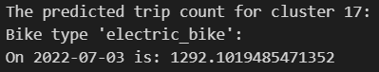

Forcasting curve:

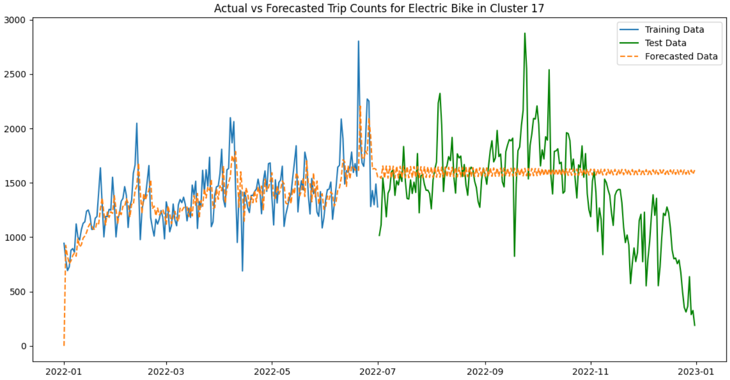

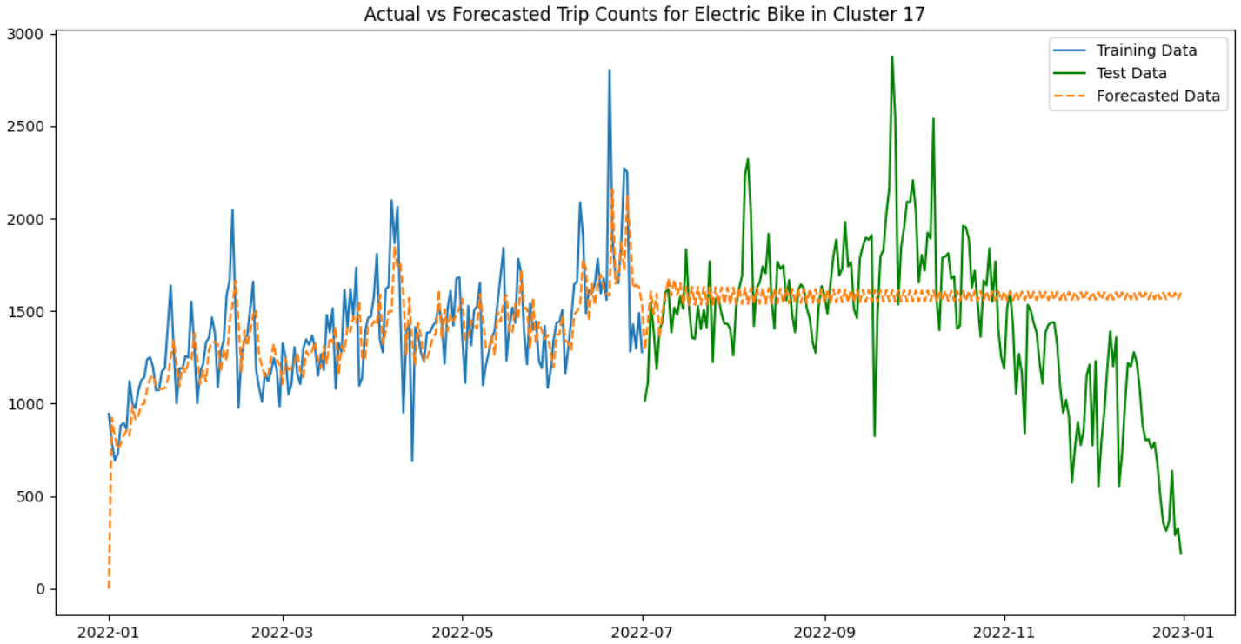

Fitting all the data

